**NUR ADIBAH BINTI ZOLKEPLI**

**2017126323**

**M3CS2453A**

1) 

- “ls” command is to know what files are in directory you are in.

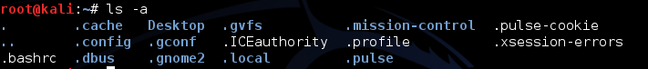

- “ls -a” is to know all the hidden files.

2) 

- “cd” command is to go to the directory.For example, if you are in the home folder, and you want to go to the dos folder,then it can be type in “cd dos”.

1. 

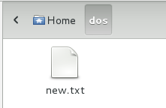

- “mv” command is to move files through the command line.



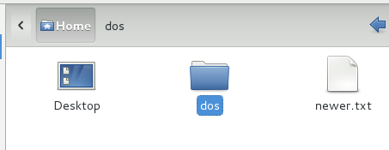

-”mv” command also can rename a file. For example change new.txt to newer.txt.

4) 

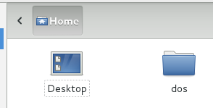

- “mkdir” command is use to create a folder or a directory. For example, if you want to make directory called “dos”, then you can type “mkdir dos”.



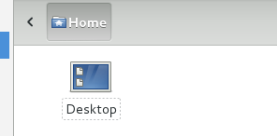

- “rmdir” command is to delete the directory but rmdir can only delete an empty directory.

1. 

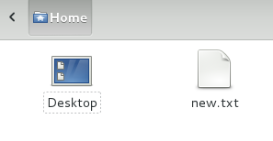

- “touch” command is use to create a file.It can be anything, from an empty txt file to an empty zip file.

1. 

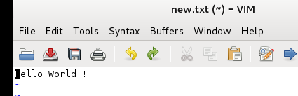

- “cat” command is to display the content of a file.

1. 

- “pwd” command is to know which directory you are in.It gives us the absolute path, which means the path that starts from the root.

1. 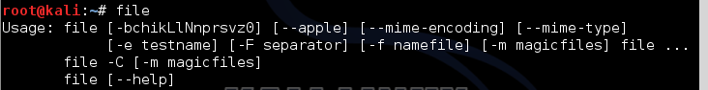

- “file” command is to test each argument in an attempt to classify it.There are three sets os tests,performed in this order.First, filesystem tests, magic tests, and language tests.



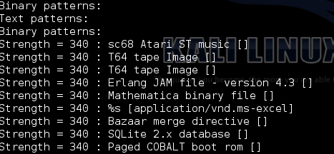

- “file -l” command is to print information about the strength of each magic pattern.

1. 

- “chmod” command is to make a file executable and to change permission granted to it in linux.

1. 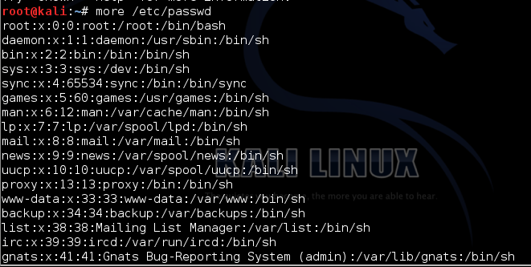

- “more” command is to view files or other output in a scroll able manner. It displays the text one screen-full at a time.



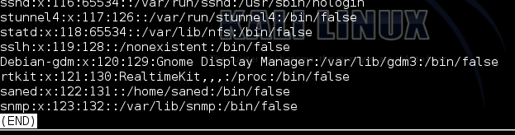

- “less” command works similarly to the “more” command but has a few improved options. For example if you want to read through a large text file it is better to use “less” command over an editor as it does not load the entire thing into memory.

1. 

- “grep” command is use to serach text. It searched the given file for lines containing a match to the given strings or words.

1. 

- “wc” or “word count” command is to prints a count of newlines,words, and bytes for each input file.

- The picture above displays information about the file new.txt. Where 1 is the number of lines, 3 is the number of words, and 14 is the number of characters.

1. 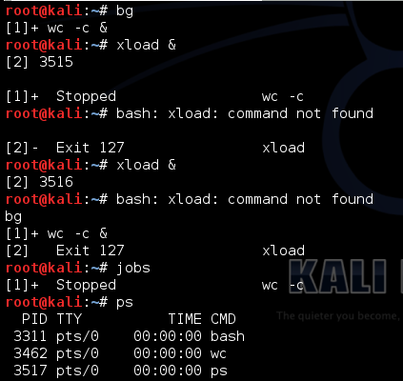

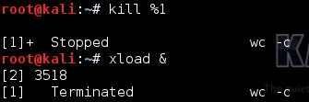

- “bg” command is to put a process in the background.

- “jobs” command is an alternate way of listing your own processes.

- “ps” command is the list processes running on the system.

- “kill” command is to send a signal to one or more processes (usually to kill a process).

1. 

- “uname” command is to show the information about the system your linux distro is running. Using the command “uname -a” prints most of the information about the system. This prints the kernel release date, version, processor type and etc.

1. 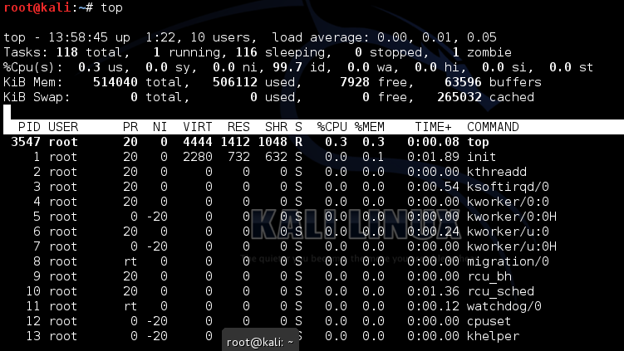

- “top”command allows users to monitor processes and system resources usage on linux.



- There is quite a bit going on in top’s interface, so it will break it down bit by bit in the next section.

1. 

- “uptime” command gives the time for which the system has been up (or running).

1. 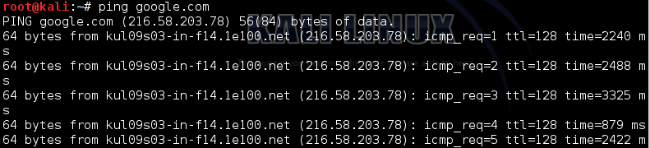

- “ping” command is to check connection to a sever. Ping is a computer network administration software utility used to test the reach-ability of a host on an IP network.

1. 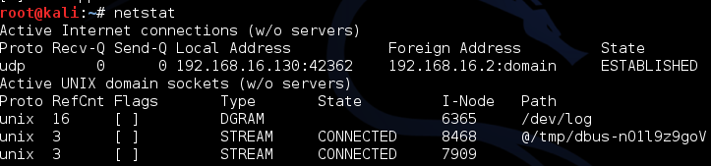

- “netstat” is a command line tool for monitoring network connection both incoming and outgoing as well as viewing routing tables, interface statistics etc.

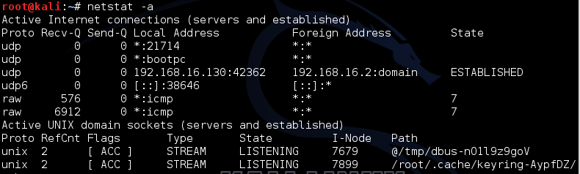

- “netstat -a” is a command to listing all ports (both TCP and UDP).

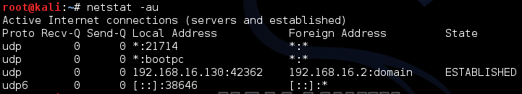

- “netstat -au” is a command to listing only UDP (User Datagram Protocol) port connection.

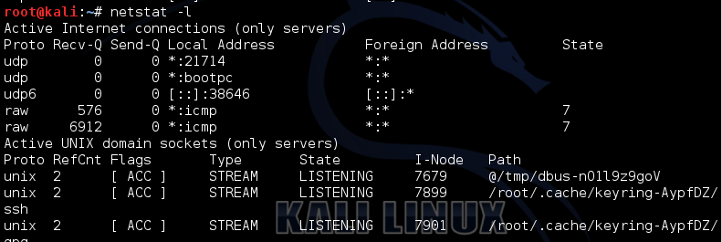

- “netstat -l” is a command to listing all active listening ports connection.

1. 

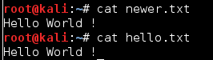

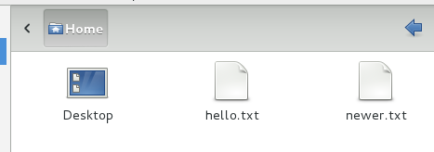

- ln creates links between files.

- The link command does is allow us to manually create a link to file data that already exist.

- So, we create our own link to the file data we just created. In essence, we’ll create another file name for the data that already exist.

- Use “link” command to make the both file have same data.

1. 

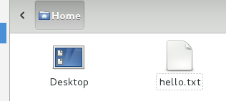

- “rm” command is to delete one of the file that we had created through the “link” command.